Kubernetes Task-8
- Create and Test a Kubernetes Pod with an EmptyDir Volume
- Configure a HostPath Volume in Kubernetes and Validate Data Persistence
- Deploy an Amazon EBS Volume Using Persistent Volume and Persistent Volume Claim (PVC)
- Set Up an Amazon EFS Volume and Attach it to Multiple Pods
- Implement and Test Liveness and Readiness Probes in a Kubernetes Pod
1.
Step 1: Create the YAML file
Create a file named emptydir-pod.yaml
vi emptydir-pod.yaml
apiVersion: v1
kind: Pod
metadata:
name: emptydir-pod
spec:
containers:
- name: nginx
image: nginx
volumeMounts:
- name: cache-volume
mountPath: /usr/share/nginx/html
volumes:
- name: cache-volume
emptyDir: {}
apply this command
kubectl apply -f emptydir-pod.yaml
Kubectl get pods

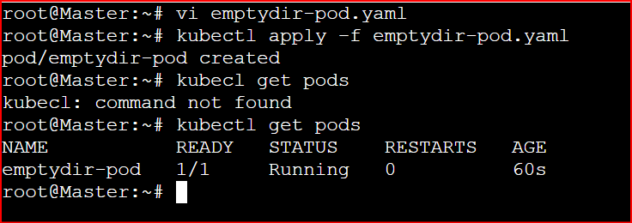

Write data inside the volume
kubectl exec -it emptydir-pod -- bash
Inside the container:
echo "Hello from EmptyDir Volume" > /usr/share/nginx/html/test.html
cat /usr/share/nginx/html/test.html

exit

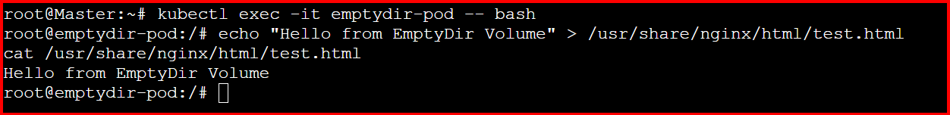

Delete and recreate the Pod
Delete the Pod:
kubectl delete pod emptydir-pod
Recreate it:
kubectl apply -f emptydir-pod.yaml

Verify data persistence
Check again:
kubectl exec -it emptydir-pod -- cat /usr/share/nginx/html/test.html
Output:
cat: /usr/share/nginx/html/test.html: No such file or directory
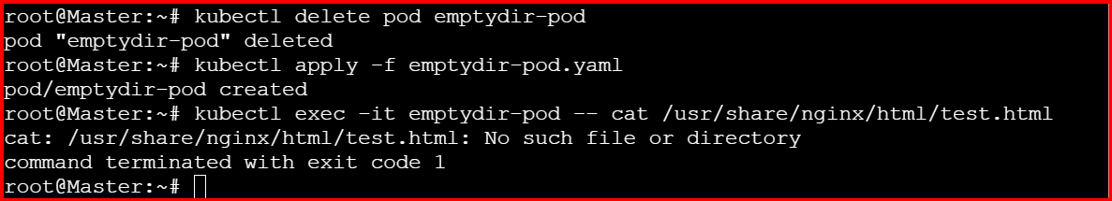

2. Configure a HostPath Volume in Kubernetes and Validate Data Persistence

vi hostpath-pod.yaml
apiVersion: v1
kind: Pod
metadata:
name: hostpath-pod
spec:
containers:
- name: nginx
image: nginx
volumeMounts:
- name: host-volume
mountPath: /data
volumes:
- name: host-volume
hostPath:
path: /mnt/hostdata
type: DirectoryOrCreate
Apply the changes
kubectl apply -f hostpath-pod.yaml
kubectl get pods

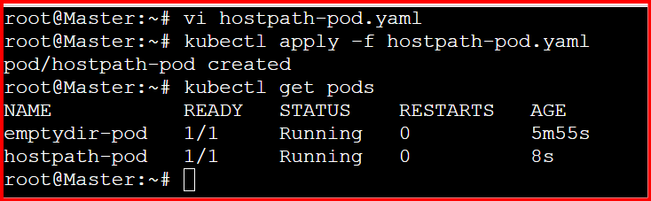

Write Data to HostPath
kubectl exec -it hostpath-pod – bash

Inside the pod

echo "Persistent data from HostPath" > /data/test.txt
cat /data/test.txt

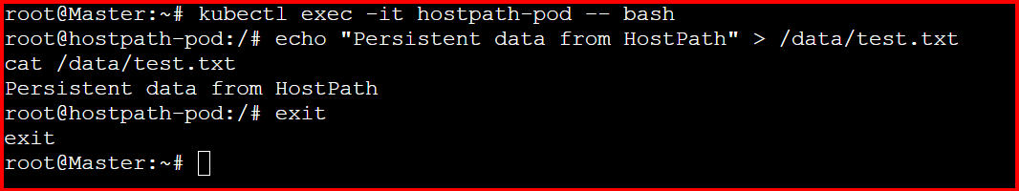

Check Data on Node:
SSH into your Kubernetes node (if you can access it) and check
cat /mnt/hostdata/test.txt

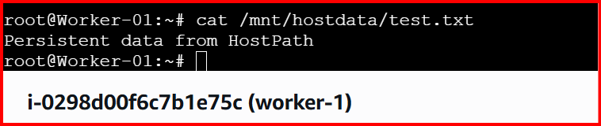

Delete and Recreate the Pod
kubectl delete pod hostpath-pod
kubectl apply -f hostpath-pod.yaml
Once the new Pod is running:
kubectl exec -it hostpath-pod -- cat /data/test.txt

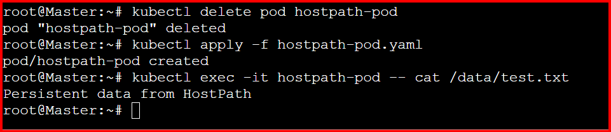

3.Deploy an Amazon EBS Volume Using Persistent Volume and Persistent Volume Claim (PVC)
Create an Amazon EBS Volume:\

Aws Configure

aws ec2 create-volume \
--availability-zone us-east-1d \
--size 20 \
--volume-type gp3
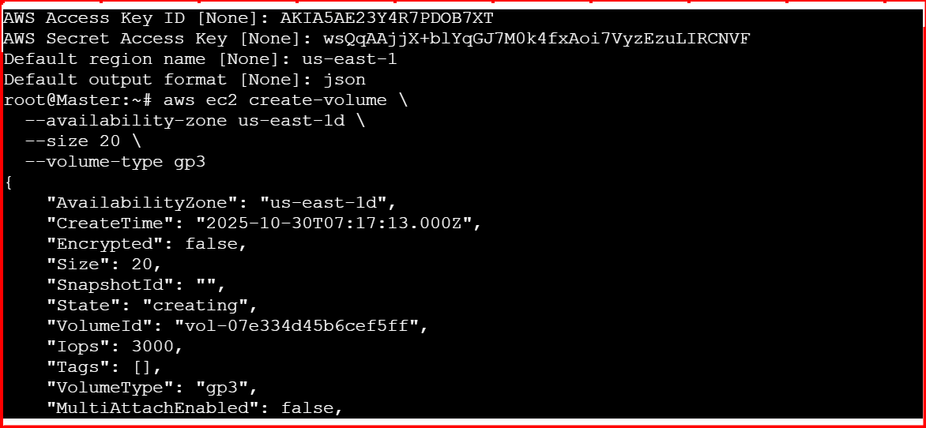

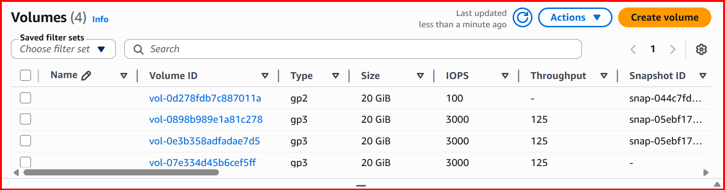
Copy the volume id
Vi pu.yml

apiVersion: v1
kind: PersistentVolume
metadata:
name: ebs-pv
spec:
capacity:
storage: 10Gi
volumeMode: Filesystem
accessModes:
- ReadWriteOnce
persistentVolumeReclaimPolicy: Retain
storageClassName: manual
csi:
driver: ebs.csi.aws.com
volumeHandle: vol-07e334d45b6cef5ff # Replace with your EBS volume ID

kubectl apply -f pu.yml
kubectl get pods
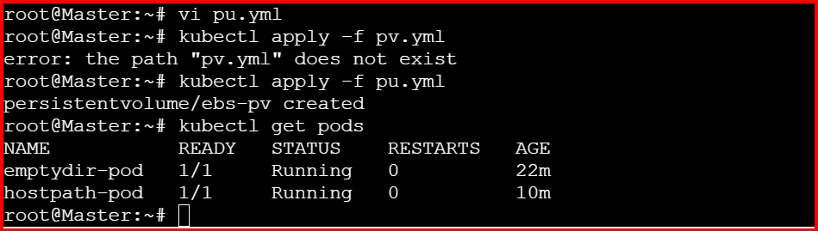

Create a Persistent Volume Claim (PVC)
vi pvc.yml

apiVersion: v1
kind: PersistentVolumeClaim
metadata:
name: ebs-pvc
spec:
accessModes:
- ReadWriteOnce
storageClassName: manual
resources:
requests:
storage: 10Gi

kubectl apply -f pvc.yml
kubectl get pods
kubectl get pvc
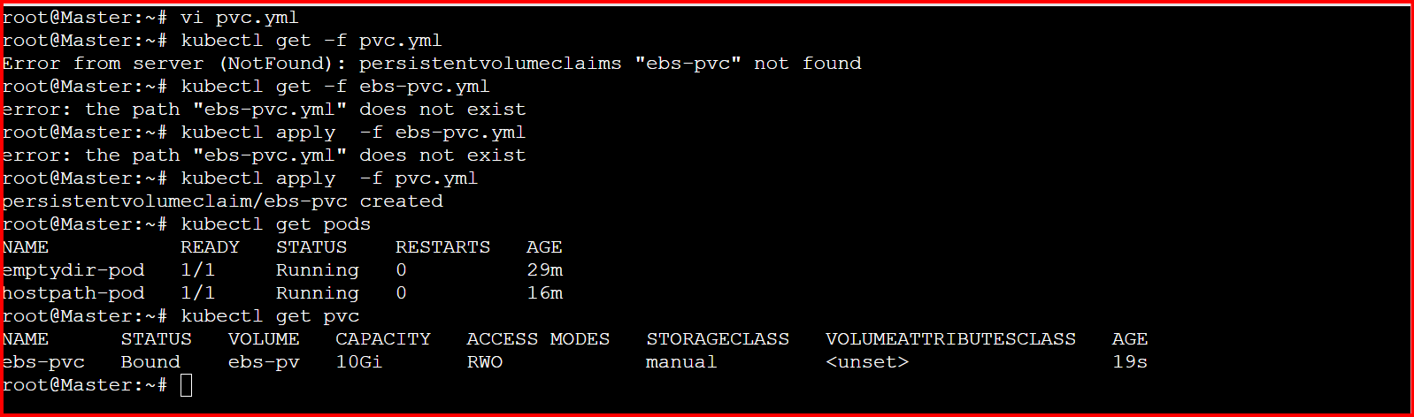

Create a Pod that Uses the PVC
vi pod.yml
apiVersion: v1
kind: Pod
metadata:
name: app-using-ebs
spec:
containers:
- name: app
image: nginx
volumeMounts:
- mountPath: /usr/share/nginx/html
name: ebs-storage
volumes:
- name: ebs-storage
persistentVolumeClaim:
claimName: ebs-pvc
kubectl apply -f pod.yml
kubectl get pods
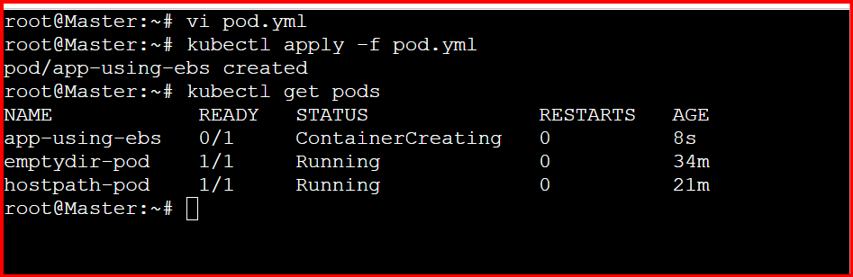

4.Set Up an Amazon EFS Volume and Attach it to Multiple Pods

Create one EFS Volume AWS Console
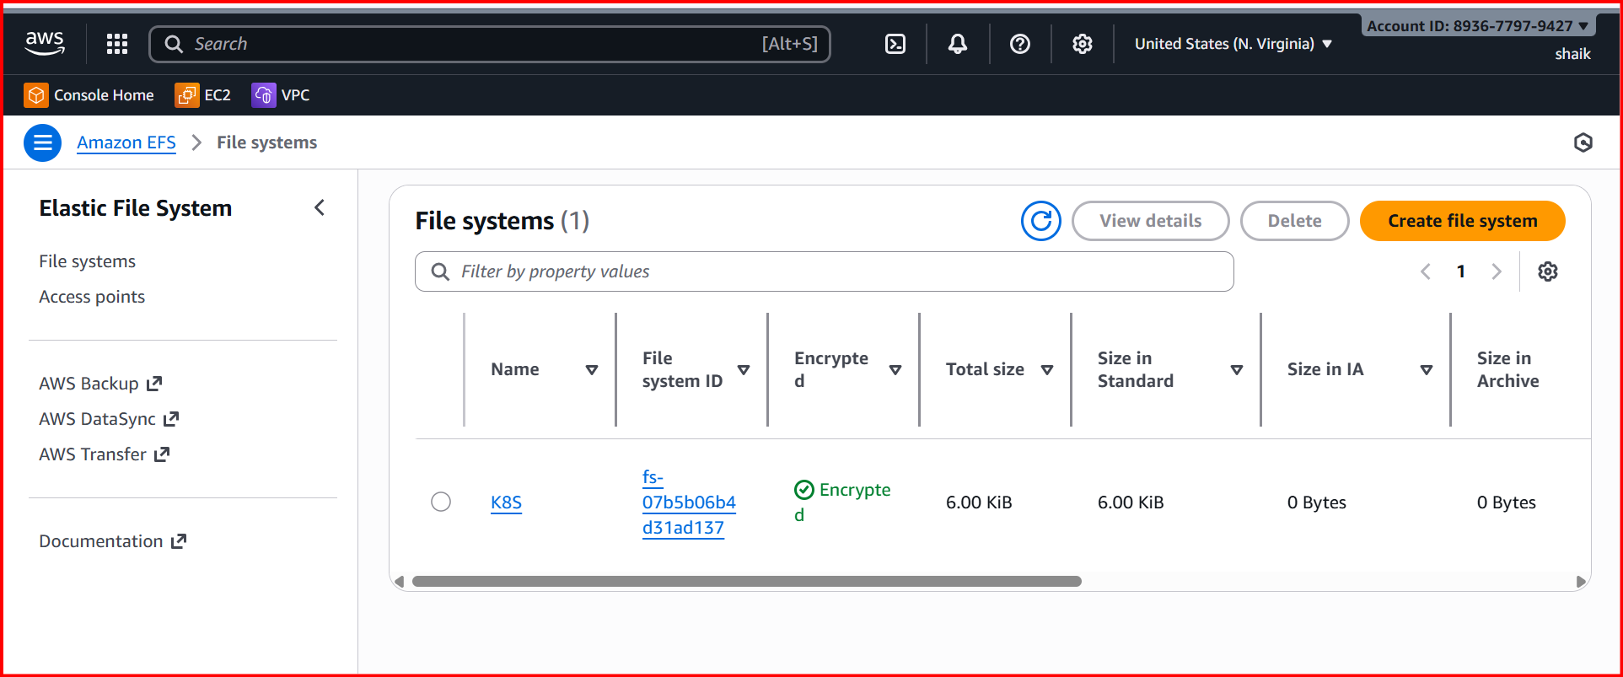
Create a access point via CLI

aws efs create-access-point \
--file-system-id fs-07b5b06b4d31ad137 \
--posix-user Uid=1000,Gid=1000 \
--root-directory 'Path=/data,CreationInfo={OwnerUid=1000,OwnerGid=1000,Permissions=755}'
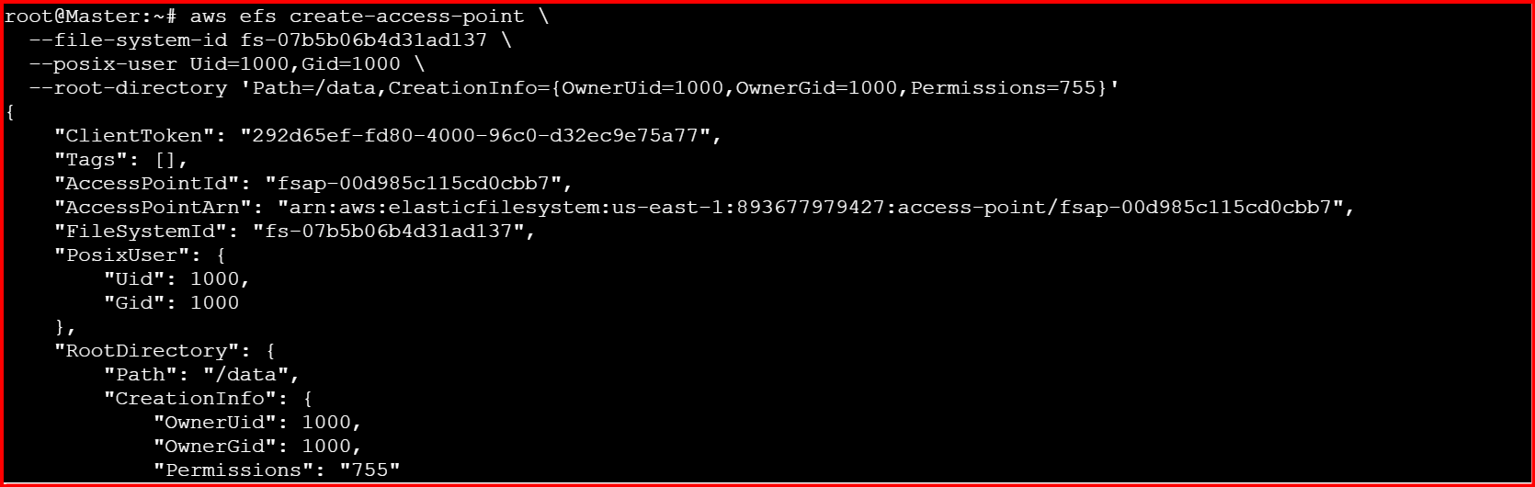
Install EFS CSI Driver on Kubernetes:
git clone https://github.com/kubernetes-sigs/aws-efs-csi-driver.git
cd aws-efs-csi-driver/deploy/kubernetes/overlays/stable/
kubectl apply -k .
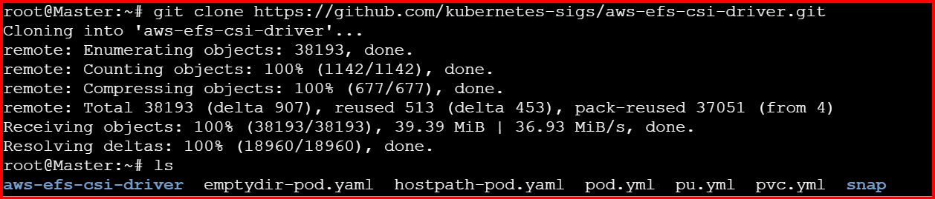
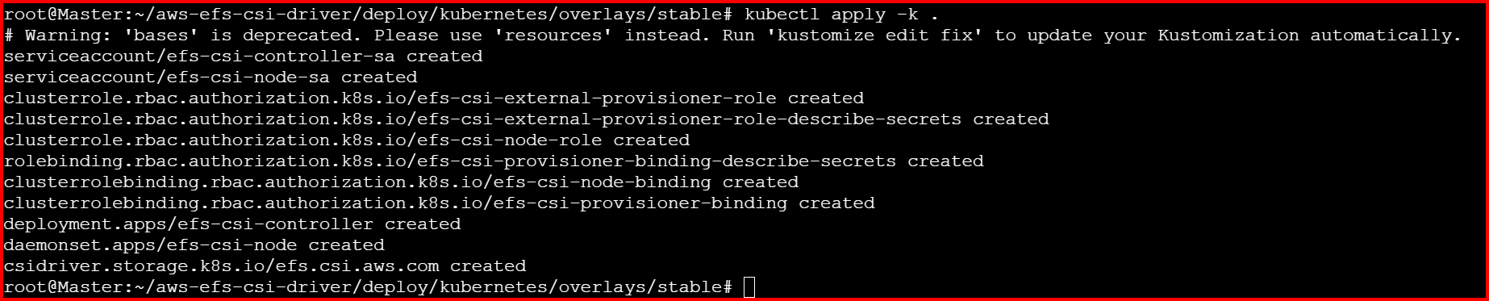
Verify this
kubectl get pods -n kube-system -l app=efs-csi-controller
kubectl get pods -n kube-system -l app=efs-csi-node
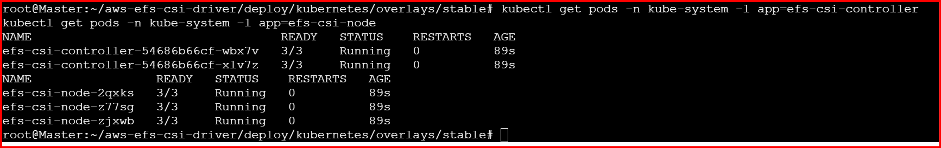

Create a StorageClass
File: storageclass.yaml
apiVersion: storage.k8s.io/v1
kind: StorageClass
metadata:
name: efs-sc
provisioner: efs.csi.aws.com

Apply:
kubectl apply -f storageclass.yaml
kubectl get sc
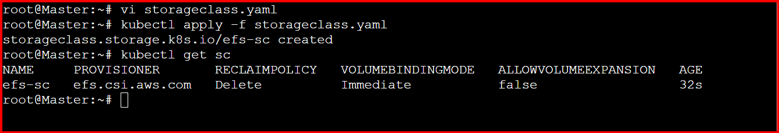
Create a Persistent Volume:
File: pv.yaml
Replace the volume Handle with your EFS File System ID and Access Point ID.
apiVersion: v1
kind: PersistentVolume
metadata:
name: efs-pv
spec:
capacity:
storage: 5Gi
accessModes:
- ReadWriteMany
persistentVolumeReclaimPolicy: Retain
storageClassName: efs-sc
csi:
driver: efs.csi.aws.com
volumeHandle: fs-07b5b06b4d31ad137::fsap-00d985c115cd0cbb7

kubectl apply -f pv.yaml
kubectl get pv
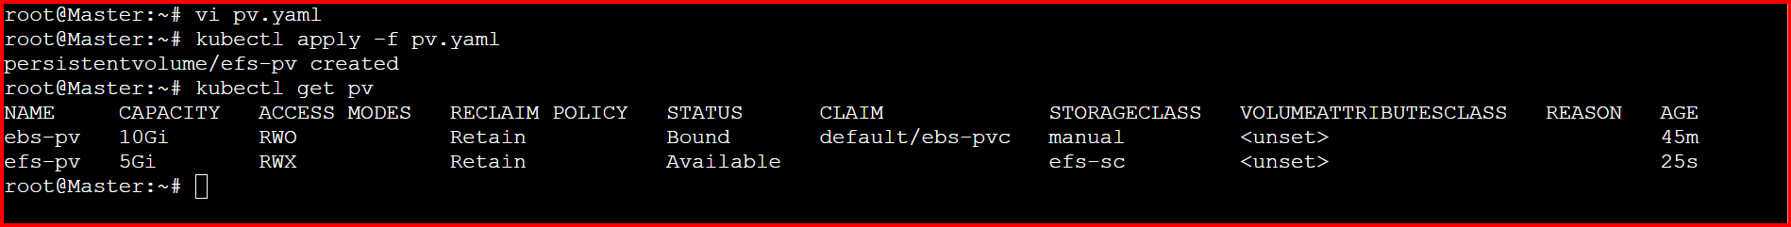

Create a Persistent Volume Claim (PVC)
File: pvc.yaml
apiVersion: v1
kind: PersistentVolumeClaim
metadata:
name: efs-claim
spec:
accessModes:
- ReadWriteMany
storageClassName: efs-sc
resources:
requests:
storage: 5Gi
Apply:
kubectl apply -f pvc.yaml
kubectl get pvc
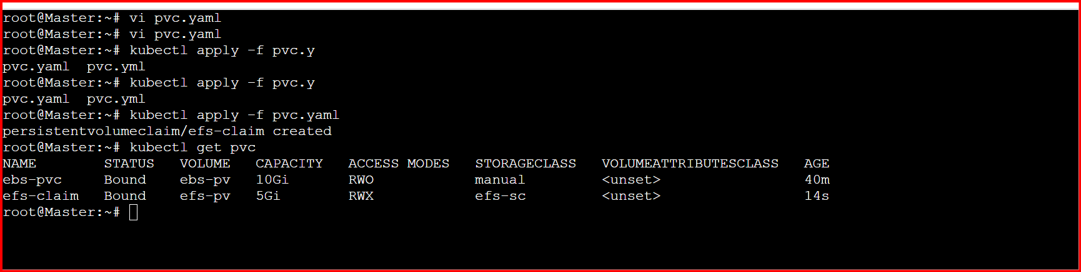

Create Multiple Pods Using the Same EFS Volume:
File: multi-pod-efs.yaml
apiVersion: v1
kind: Pod
metadata:
name: pod1
spec:
containers:
- name: app1
image: nginx
volumeMounts:
- name: efs-storage
mountPath: /usr/share/nginx/html
volumes:
- name: efs-storage
persistentVolumeClaim:
claimName: efs-claim
---
apiVersion: v1
kind: Pod
metadata:
name: pod2
spec:
containers:
- name: app2
image: nginx
volumeMounts:
- name: efs-storage
mountPath: /usr/share/nginx/html
volumes:
- name: efs-storage
persistentVolumeClaim:
claimName: efs-claim

Write from Pod 1

kubectl exec -it pod1 -- bash
echo "Hello from Pod1" > /usr/share/nginx/html/test.html
exit

Read from Pod 2:
kubectl exec -it pod2 -- cat /usr/share/nginx/html/test.html

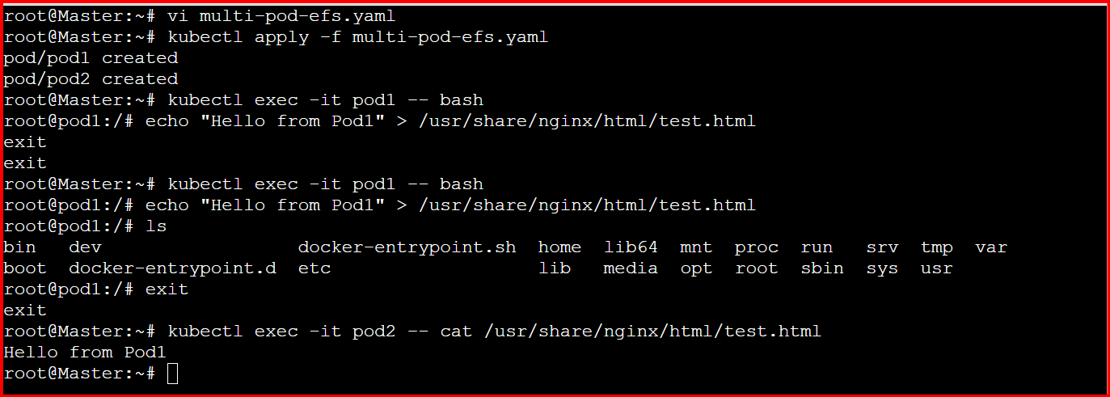

5.Implement and Test Liveness and Readiness Probes in a Kubernetes Pod.
Pod with Liveness & Readiness Probes:
File: liveness-readiness-pod.yaml
apiVersion: v1
kind: Pod
metadata:
name: probe-demo
labels:
app: probe-test
spec:
containers:
- name: nginx
image: nginx
ports:
- containerPort: 80
# Liveness probe: ensures the container is still alive
livenessProbe:
httpGet:
path: /
port: 80
initialDelaySeconds: 10 # Wait 10s after start before first check
periodSeconds: 5 # Check every 5 seconds
failureThreshold: 3 # After 3 failed checks → restart container

# Readiness probe: ensures the container is ready to serve traffic
readinessProbe:
httpGet:
path: /
port: 80
initialDelaySeconds: 5 # Start checking after 5s
periodSeconds: 5
failureThreshold: 3

kubectl apply -f liveness-readiness-pod.yaml

kubectl get pods
kubectl describe pod probe-demo
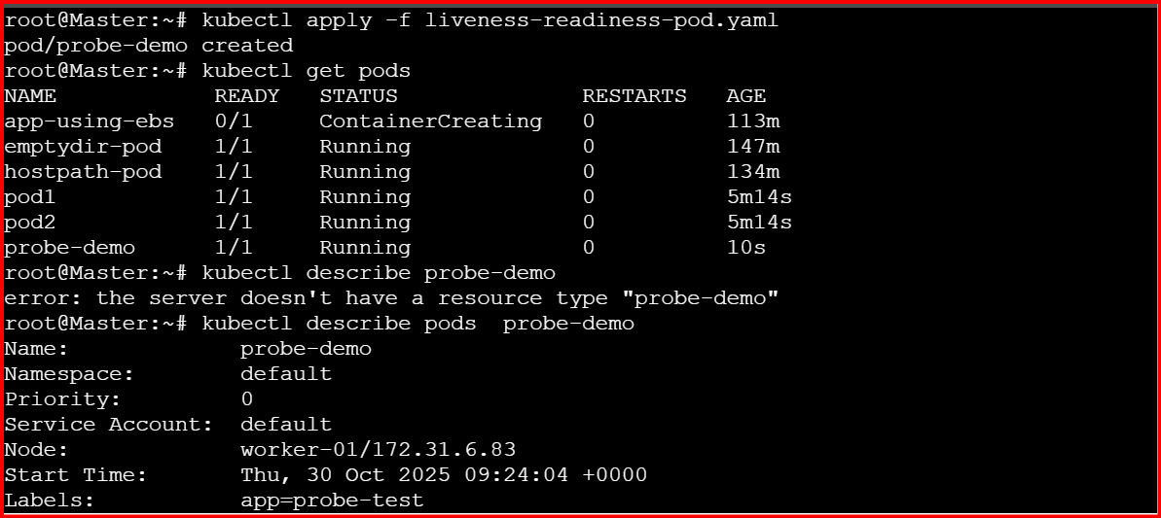

You’ll see probe details under the container section:
Liveness: http-get http://:80/ delay=10s timeout=1s period=5s #success=1 #failure=3
Readiness: http-get http://:80/ delay=5s timeout=1s period=5s #success=1 #failure=3
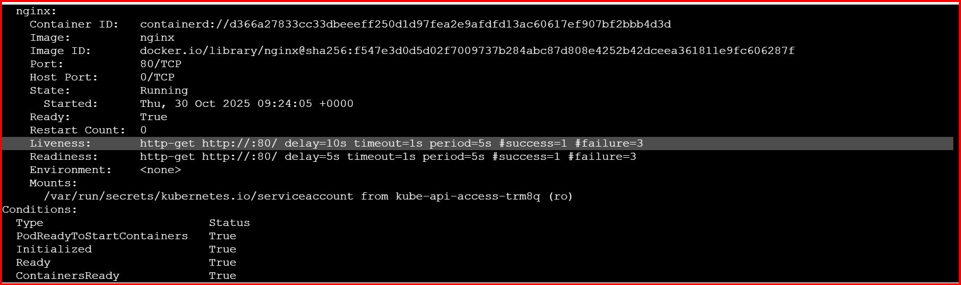
Test the Liveness Probe:
Get inside the Pod:
kubectl exec -it probe-demo -- bash

Remove the default nginx index file (to break the app):
rm -rf /usr/share/nginx/html/*
exit

Wait a few seconds, then run:
Kubectl get pods
You’ll notice the RESTARTS count increases
